How to use these scripts

Contents

Install these scripts

Using scripts in Mentor Xpedition Layout through menu bar

Illustration of scripts

Install these scripts

Unzip these file to local disk, like D:\EETB_2412\

Add EETB file path to WDIR environment variable, so Xpedition can find the scripts.ini file and execute it when started. Make sure the AATK folder is not the first path in the WDIR definition as the first path is also used for temporary space by various Xpedition tools and is stores the users default Xpedition environment.

For VX you have to add the EETB path to the release specific WDIR variables as below.

For VX.2.10 it would be:

WDIR_EEVX_2_10=C:\WDIR\EEVX.2.10;D:\EETB_2412

For XPENTP2409 it would be:

WDIR_XPENTP2409=C:\WDIR\XPENTP2409;D:\EETB_2412

Define a EETB environment variable, the value is the pathname of EETB directory you just unzipped. So we can run these scripts correctly.

EETB_2412=D:\EETB_2412

Using scripts in Mentor Xpedition Layout through menu bar

A EETB menu will appear in the last position of menu bar when you open a project. You can run scripts through clicking menu button under EETB menu.

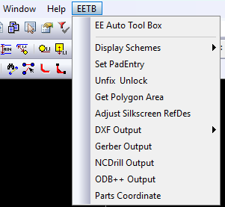

Illustration of scripts

Constraint:

SetPadEntry.vbs : this script will set rules of pad entry. It’s the same to behaviors we do in “Pad Entry” Dialog in Editor Control. Rules will be check as below.

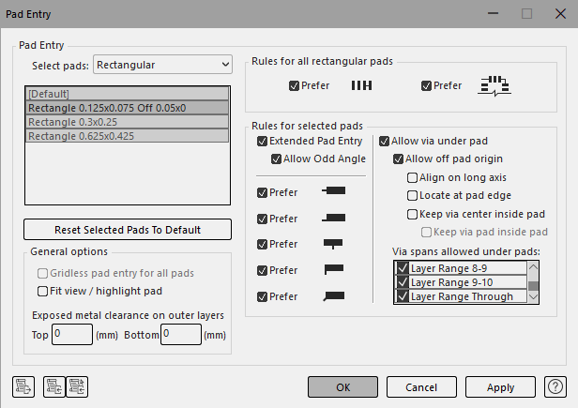

Display:

ColorGndPwrNets.vbs : this script will color GND/PWR nets. All nets that match the reg expression as below will be colored.

GND = "*GND*"

PWR = "*VREG*", "*VDD*", "*VCC*", "*VBUS*", "*VSIM*", "*VPH*", "*PWR*", "*VBAT*"

ColorNetClasses.vbs : this script will color nets class which named like Z*[0-9*]* and so on.

DisplayNormalView.vbs : this script will uncheck the "Mirror View" option in display control window.

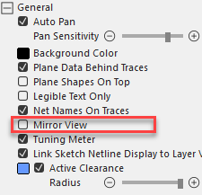

DisplaySchemeAssemblyTop.vbs & DisplaySchemeAssemblyBottom.vbs : this scripts will show a assembly view, which contains board outlines, cutout and components information which contain silkscreen, RefDes, soldermask pad, solderpaste pad and so on. Of course it will hide any other layers, trace, via ,plane .

DisplaySchemeRoute.vbs : this script will show a route view, means that it will check the trace, via, plane … options and color them properly in the display control window, give us a clear view when we are routing.

ToggleDisplayPatterns.vbs :